NAAN MUDHALVAAN

APPLIED DATA SCIENCE

FUTURE SALES PREDICTION

REG.NO : 712221205013

NAME : MADHUMITHA.K

DEPT : INFORMATION TECHNOLOGY

YEAR & SEM : III & 05

COLLEGE: PARK COLLEGE OF ENGINEERING

AND TECHNOLOGY

**PHASE 5**

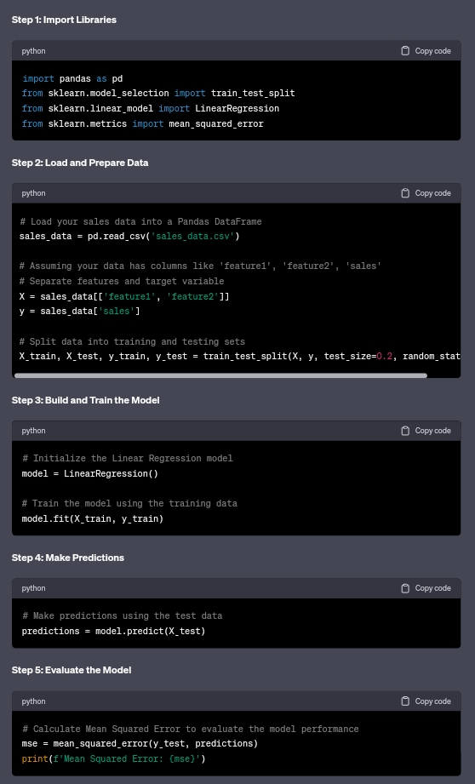

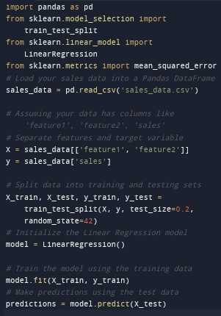PROGRAM:

Data set link:

[output for future sales prediction](https://www.kaggle.com/datasets/chakradharmattapalli/future-sales-prediction)